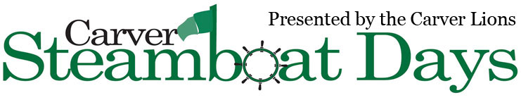

MN Marketplace
Saturday September 10, 2022
10 a.m. -5 p.m.
$30 per 10’x10’ space
Non-refundable

Vendor Registration

Owner Name: _________________________________________________________________________
Name of Business: _____________________________________________________________________
Type of Business/Activity: _______________________________________________________________
Address: _____________________________________________________________________________
Email: _______________________________________________________________________________
*Vendors must stay until the end of the day. Set up any time between 8:00am and 9:00am.
Please submit this form along with an ST19 tax form and your $30.00 (per space) non-refundable check payable to Carver Steamboat Days to: Steamboat Days – Marketplace PO BOX 268 Carver, MN 55315. Submit registration by August 15th, 2022. Registration is not complete without payment.
For more Information, please visit our Facebook page or our website at carversteamboatdays.info Email questions to: monicahron@yahoo.com

*The Steamboat Days Committee reserves the right to deny vendors with wares or content not deemed suitable or in keeping with the intended marketplace event. The Steamboat Days Committee reserves the right to deny vendors who may be duplicates of already registered vendors. In the case of denied registration a full refund will be promptly issued.

Signature: ________________________________________________Date: ______________________
____________________________________________________________________________________
To be completed by committee only
Date received _______________ Amount paid________________ Check #_________________

